Task on S3

1.Create an S3 bucket and upload some objects to S3.
Objective
To create an Amazon S3 bucket and upload objects/files into the bucket for storing data in the cloud.
Steps Performed
- Logged in to the AWS Management Console.
- Opened the S3 service.
- Clicked Create bucket.
- Entered a unique bucket name, for example:
sweety-s3-practice-2026
- Selected the required AWS Region.
- Kept the default settings for the bucket.
- Created the S3 bucket.
- Opened the newly created bucket.
- Clicked Upload.
- Selected files from the local computer.
- Clicked Upload to upload the objects.
- Verified that the uploaded files were visible in the bucket.
Evidence / Screenshots
Take screenshots of:
Screenshot 1: S3 bucket successfully created showing the bucket name.
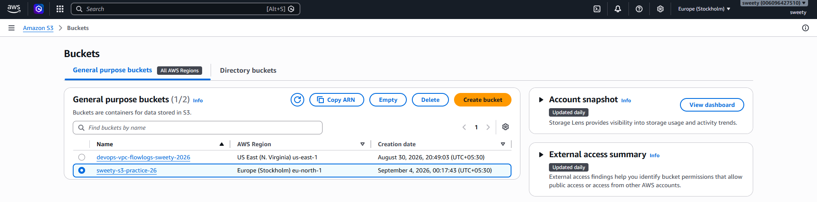

Screenshot 2: Inside the bucket showing the uploaded objects.
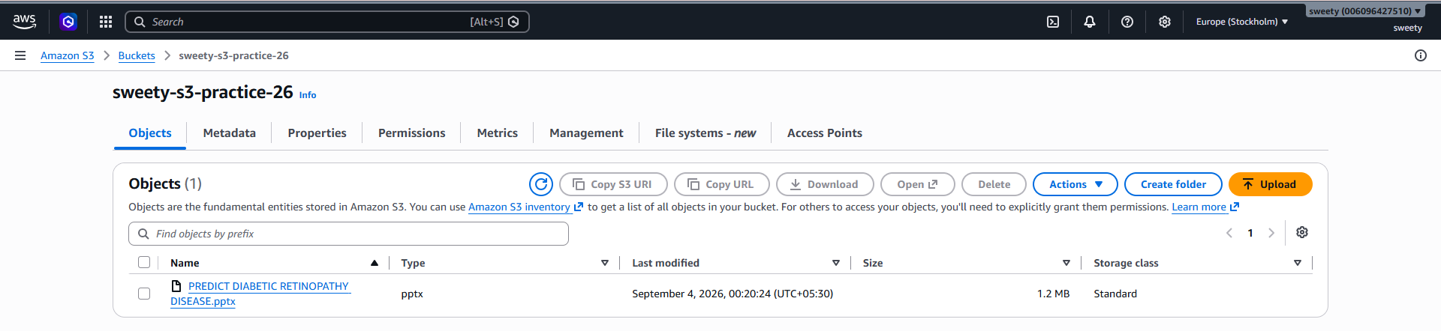
Evidence: The S3 bucket was successfully created and multiple objects were uploaded and displayed in the bucket.
Conclusion
The S3 bucket was successfully created, and objects were uploaded and stored successfully in Amazon S3.

2. Deploy a static website in the S3 bucket.
Objective
To host and deploy a static website using an Amazon S3 bucket.
Steps Performed
- Created an S3 bucket for website hosting.
- Created a simple index.html file containing HTML content.
- Uploaded the index.html file to the S3 bucket.
- Opened the bucket and went to the Properties tab.
- Located Static website hosting.
- Enabled static website hosting.
- Selected Host a static website.
- Set the index document as:
index.html
- Saved the changes.
- Configured the required bucket permissions to allow website access.
- Copied the S3 website endpoint.
- Opened the endpoint in a browser.
- Verified that the HTML page was displayed successfully.
Evidence / Screenshots
Screenshot 1: index.html visible inside the bucket.
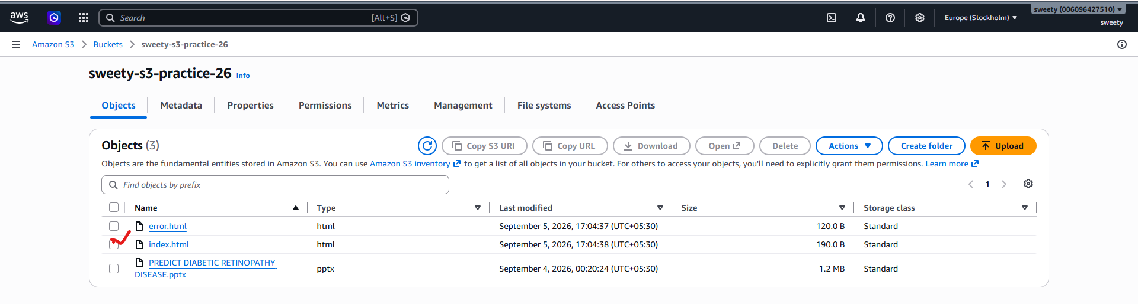
Screenshot 2: Static website hosting enabled under Properties.
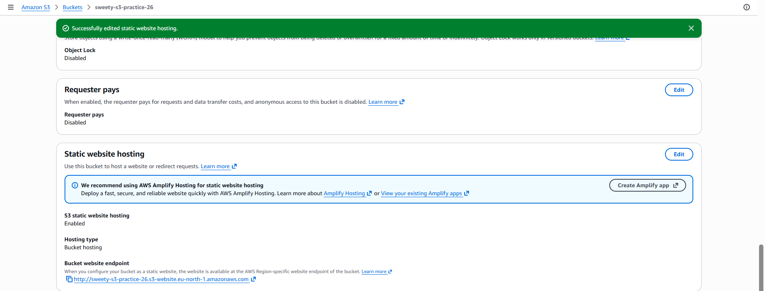
Screenshot 3: Website endpoint showing your webpage in the browser.
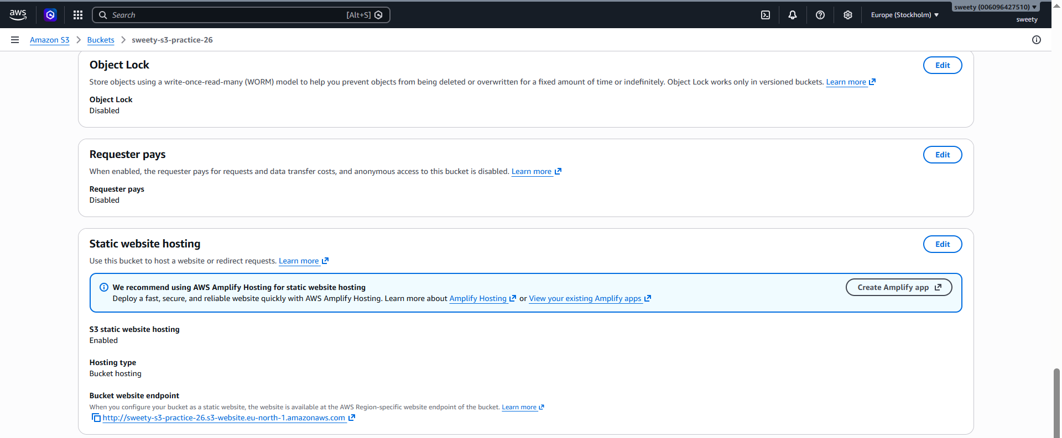
Welcome to My S3 Static Website
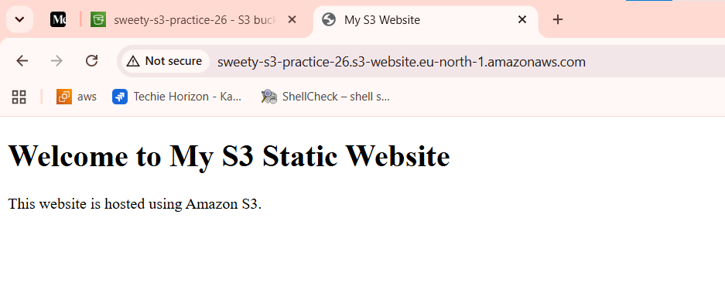

Conclusion
The static website was successfully hosted on Amazon S3 and accessed through the S3 website endpoint.

3. Enable Cross-Region Replication on S3 Buckets
Objective
To configure Amazon S3 Cross-Region Replication (CRR) so that objects uploaded to a source bucket are automatically replicated to a bucket located in another AWS Region.
Steps Performed
- Created a source S3 bucket in one AWS Region.
- Created a destination S3 bucket in a different AWS Region.
Example:
Source: us-west-1
Destination: us-east-1
- Opened the source S3 bucket.
- Went to the Management tab.
- Selected Replication rules.
- Created a new replication rule.
- Provided a replication rule name.
- Selected the scope of objects to replicate.
- Selected the destination bucket in the other AWS Region.
- Configured the required IAM role for replication.
- Saved the replication rule.
- Uploaded a new object to the source bucket.
- Opened the destination bucket.
- Verified that the object was replicated to the destination bucket.
Evidence / Screenshots
Screenshot 1: Source bucket and its Region.
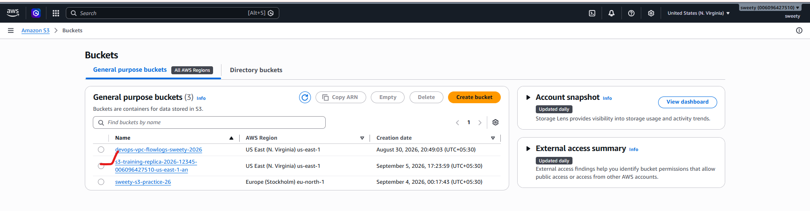
Screenshot 2: Destination bucket and its different Region.
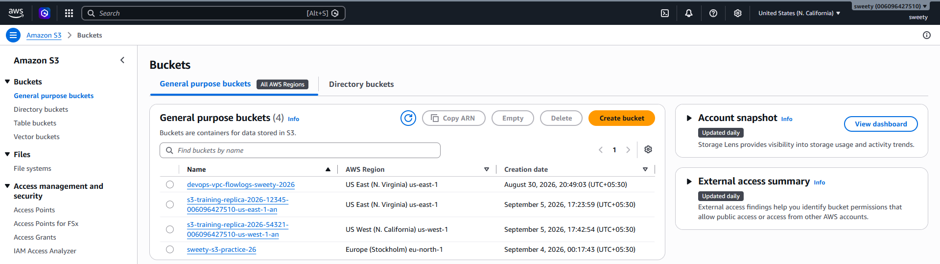

Screenshot 3: Replication rule showing source and destination.
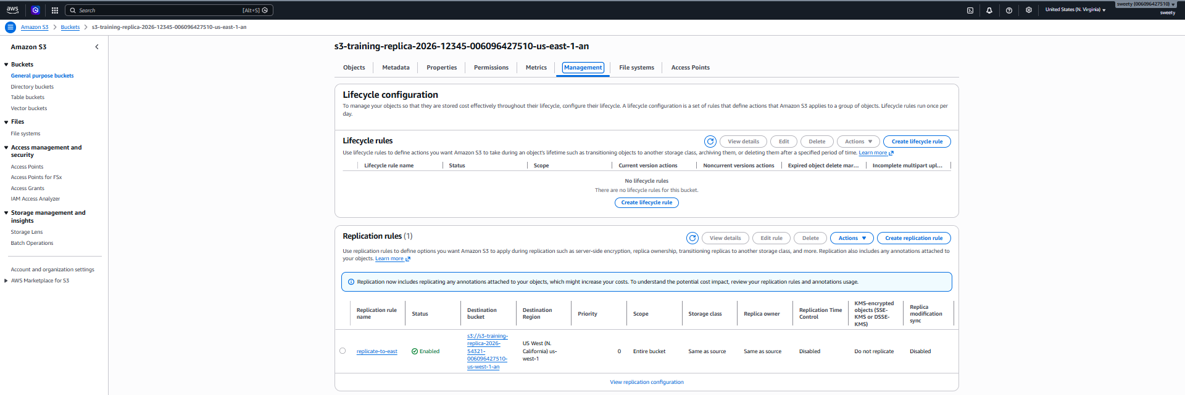
Screenshot 4: Object visible in the source bucket.
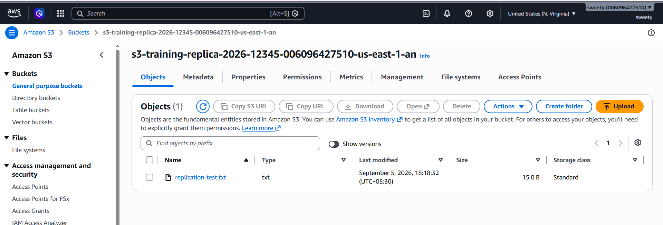
Screenshot 5: Same object visible in the destination bucket.
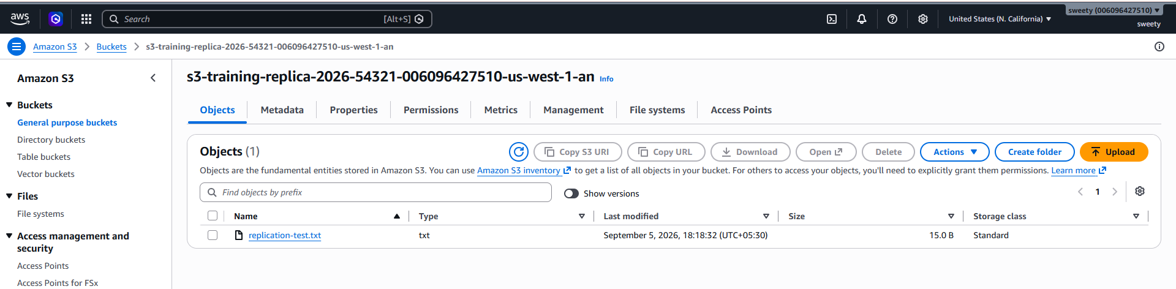

Conclusion
Cross-Region Replication was successfully configured, and objects uploaded to the source bucket were replicated to the destination bucket in another AWS Region.

Task 4: Configure Bucket Policy So Only the Admin User Can See Objects
Objective
To configure an S3 bucket policy so that only the designated Admin IAM user has permission to list and read objects from the S3 bucket.
Important
we should have:
Admin User
|
| Allowed
↓
S3 Bucket
Other users:
Other IAM User
|
| Denied
↓
S3 Bucket
Steps Performed
- Created an S3 bucket.
- Created/configured an IAM user named Admin for the practical.
- Obtained the Admin user's ARN from IAM.
- Opened the S3 bucket.
- Went to Permissions.
- Opened Bucket policy.
- Added a policy allowing the Admin user to:
  - List the bucket
  - Get objects
- Restricted access to the specified Admin principal.
- Saved the bucket policy.
- Logged in/tested using the Admin user.
- Verified that the Admin user could list and access the objects.
- Tested with another user without the required permissions.
- Verified that the other user could not access the bucket objects.
Evidence / Screenshots
Take screenshots of:
Screenshot 1: IAM Admin user.
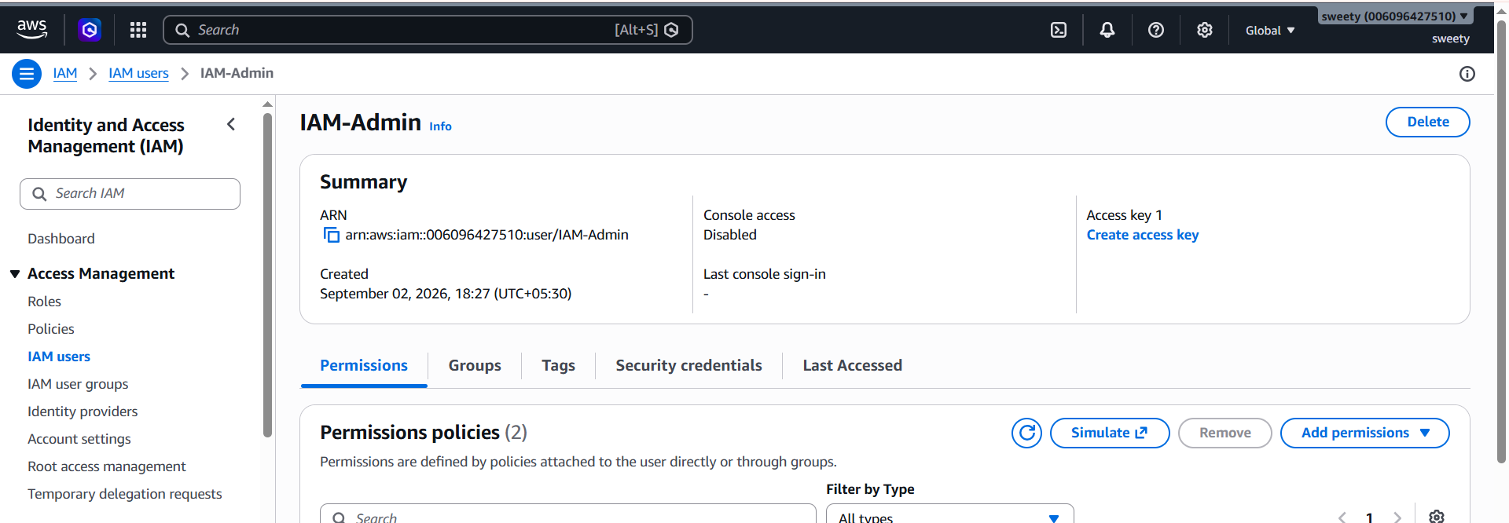
Screenshot 2: Bucket → Permissions → Bucket Policy.
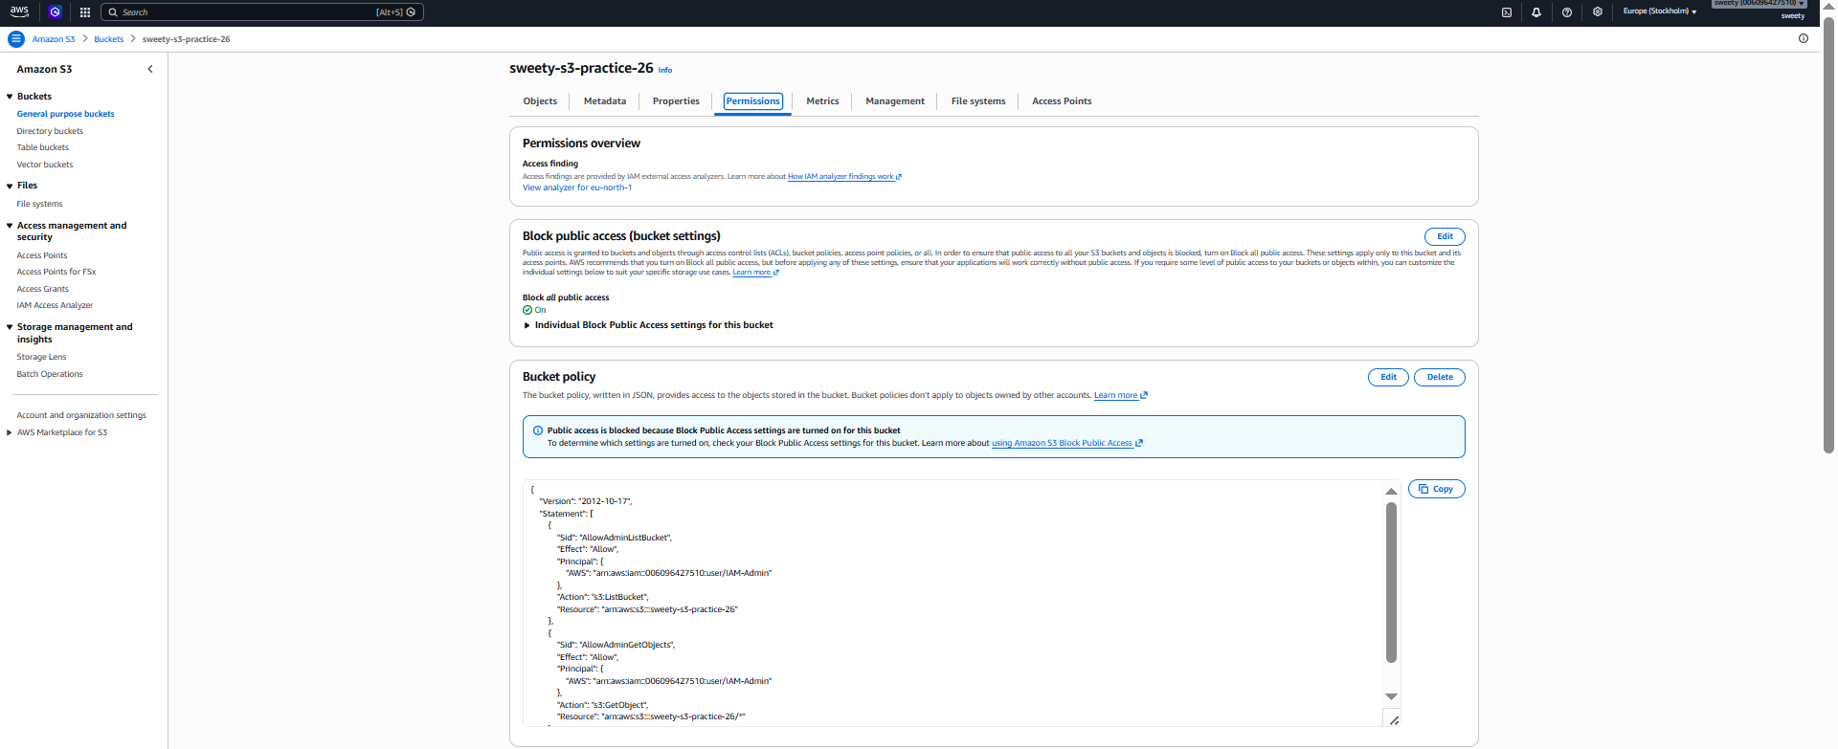
Screenshot 3: Admin user successfully viewing the objects.
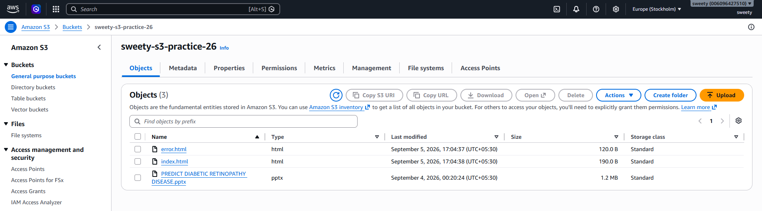

Screenshot 4: Unauthorized user receiving an Access Denied message, if you perform this test.
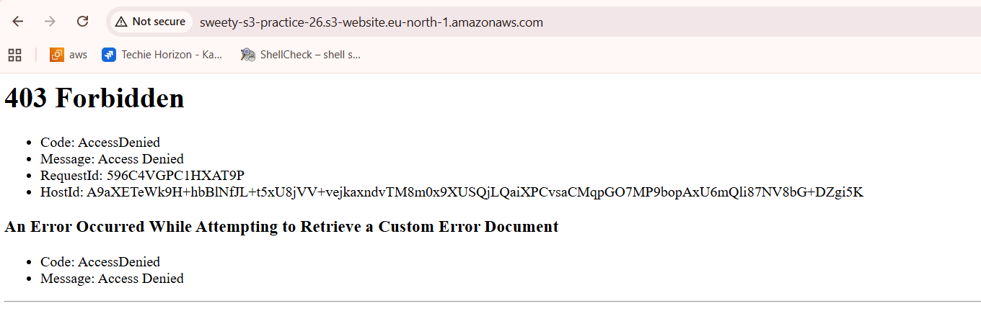
Conclusion
The S3 bucket policy was successfully configured so that only the designated Admin user could access and view the objects.

5. Configure S3 Lifecycle Policies
Objective
To configure an S3 Lifecycle policy to automatically transition objects to a different storage class or delete objects after a specified period.
Steps Performed
- Opened the S3 bucket.
- Selected the Management tab.
- Selected Create lifecycle rule.
- Entered a lifecycle rule name.
Example:
s3-lifecycle-rule
- Selected the objects to which the rule should apply.
- Configured a transition rule.
For example:
After 30 days → S3 Standard-IA
- Optionally configured an expiration rule.
Example:
After 90 days → Delete objects
- Reviewed the lifecycle configuration.
- Created/saved the lifecycle rule.
- Verified that the lifecycle rule appeared under the bucket's lifecycle configuration.
Evidence / Screenshots
Take screenshots of:
Screenshot 1: Bucket → Management → Lifecycle rules.
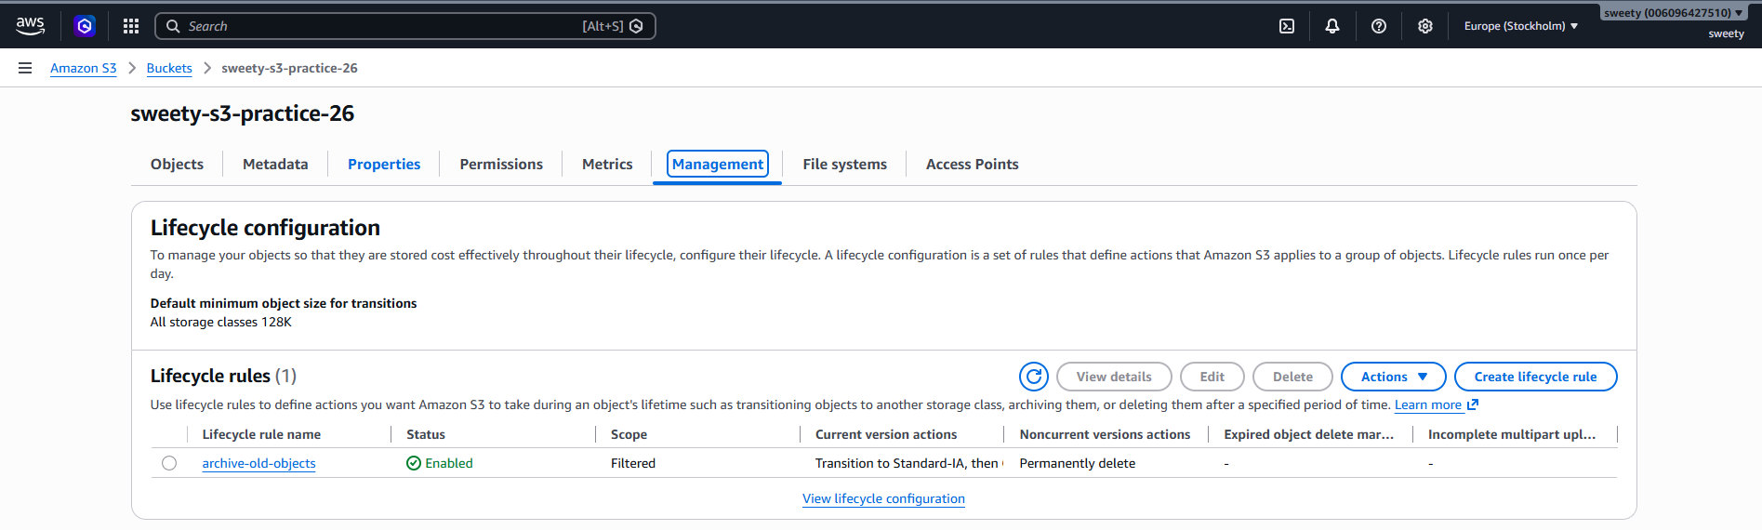
Screenshot 2: Lifecycle rule showing transition/expiration settings.
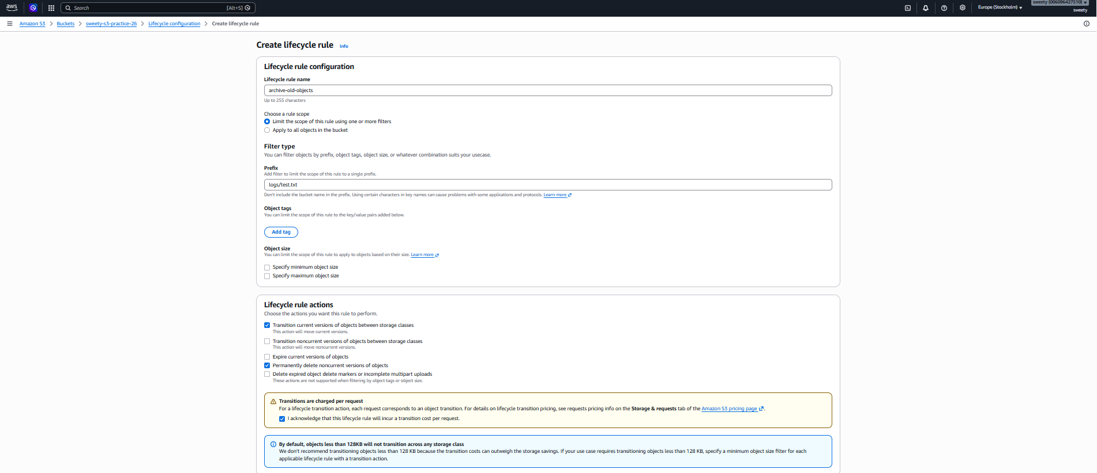
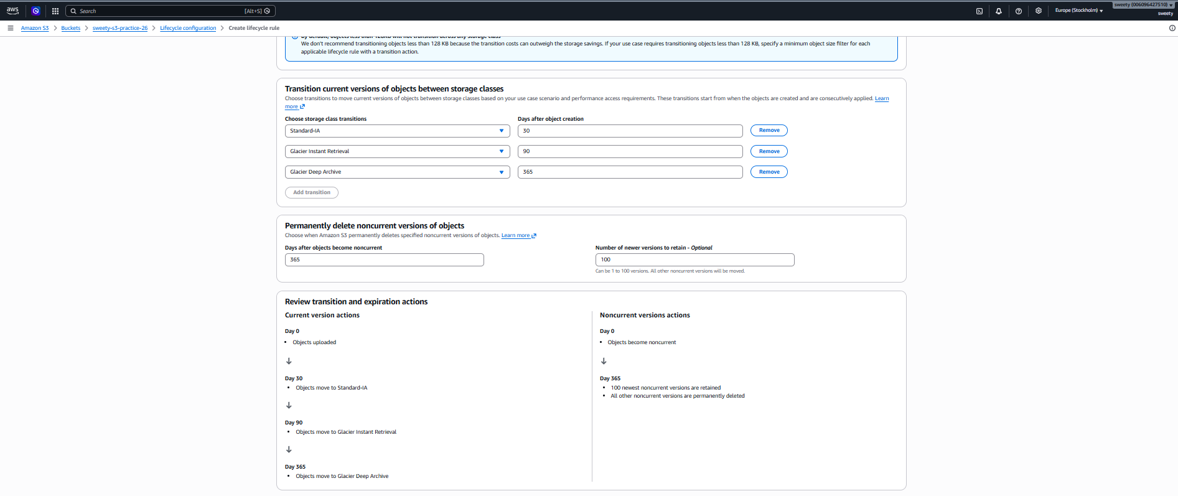
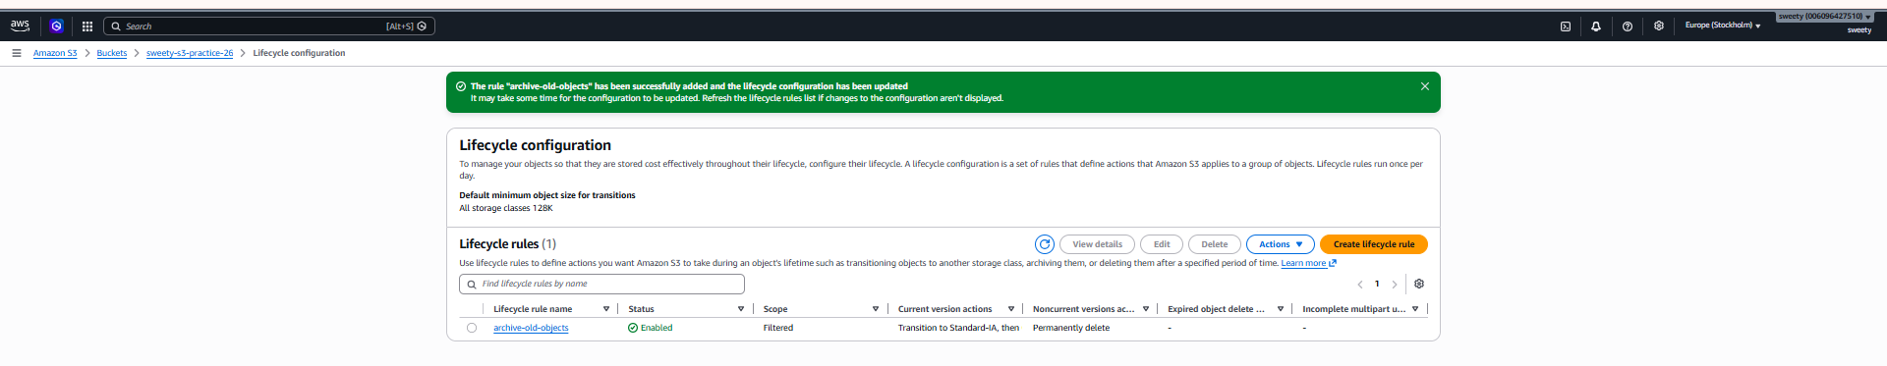
Lifecycle Rule
↓
30 Days → Standard-IA
↓
90 Days → Delete
Conclusion
The S3 Lifecycle policy was successfully configured to automatically transition and/or delete objects according to the specified criteria.

6. Push Objects to S3 Using AWS CLI
Objective
To upload files/objects to an Amazon S3 bucket using the AWS Command Line Interface (AWS CLI).
Steps Performed
- Opened Git Bash/Command Prompt/PowerShell.
- Verified that AWS CLI was installed.
aws --version
- Configured/verified AWS credentials.
aws configure
- Verified the AWS identity.
aws sts get-caller-identity
- Created a test file.
echo "This file was uploaded using AWS CLI" > test.txt
- Uploaded the file to S3.
aws s3 cp test.txt s3://YOUR-BUCKET-NAME/
- Verified the uploaded object using:
aws s3 ls s3://YOUR-BUCKET-NAME/
- Opened the S3 bucket in the AWS Console.
- Verified that test.txt was present.
Evidence / Screenshots
Take screenshots of:
aws --version
aws s3 cp test.txt s3://YOUR-BUCKET-NAME/
showing successful upload.
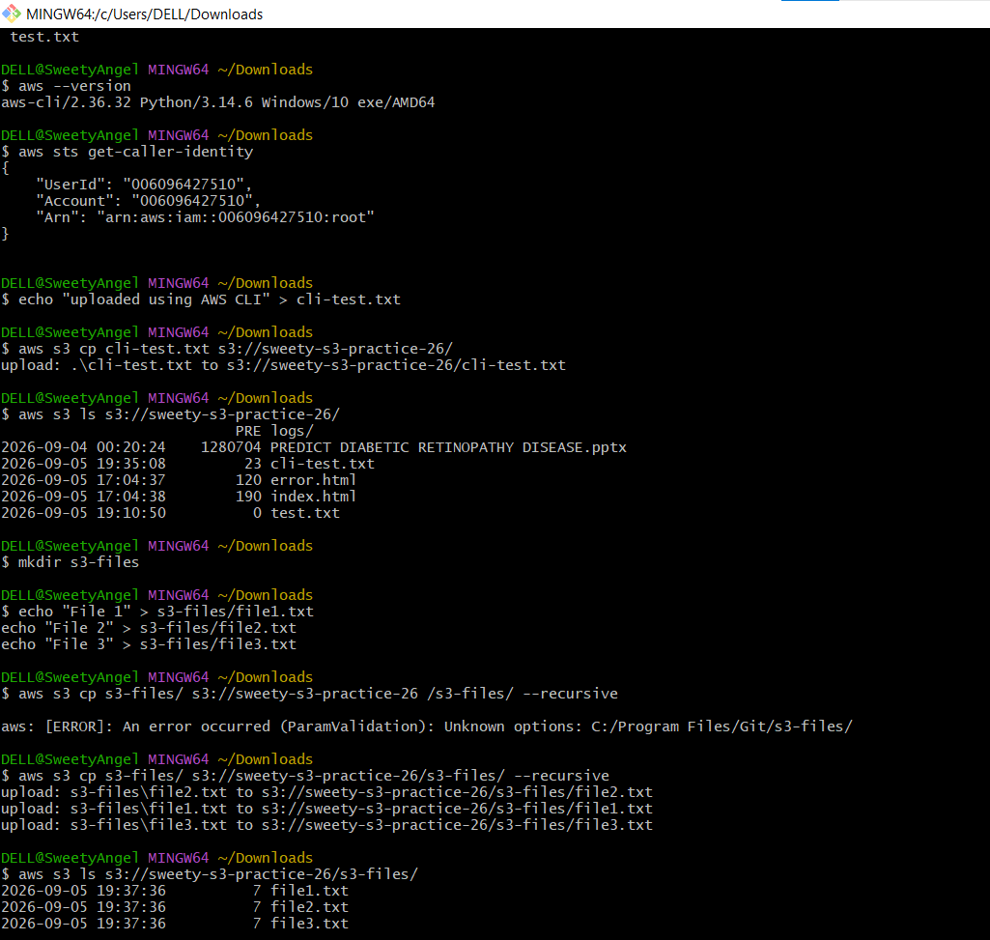
Screenshot:
aws s3 ls s3://YOUR-BUCKET-NAME/
showing the object.

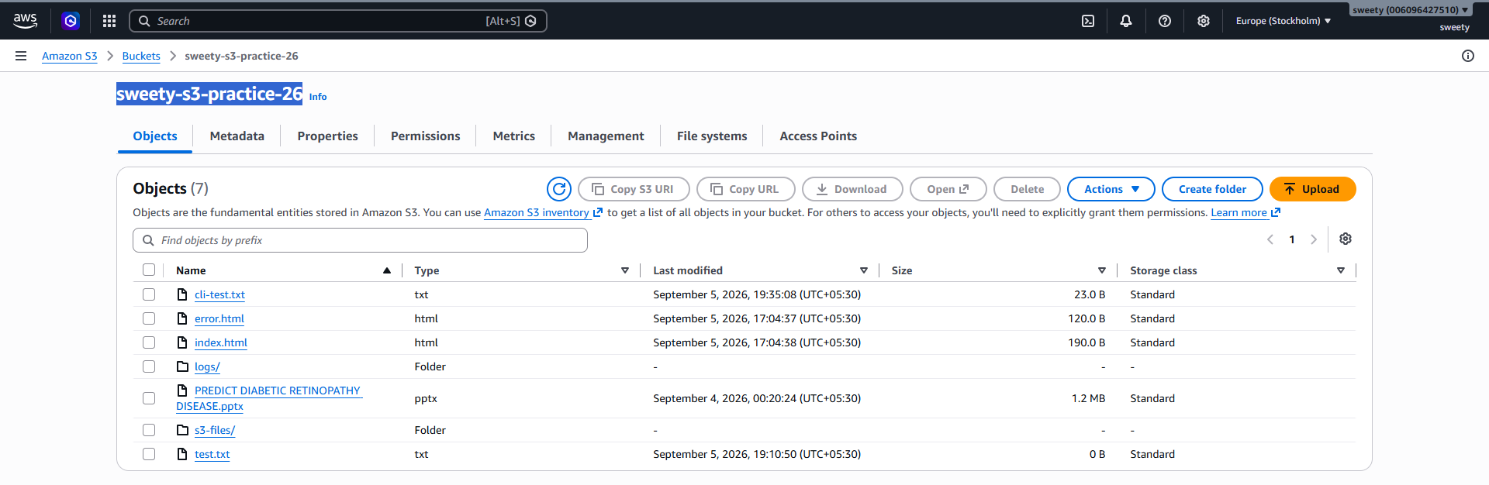

Conclusion
The object was successfully uploaded to Amazon S3 using the AWS CLI and verified through both the CLI and AWS Management Console.

7. Bash script to create an S3 bucket
Objective
To automate the creation of an Amazon S3 bucket using a Bash script and AWS CLI.
Steps Performed
- Opened Git Bash/Linux terminal.
- Created a Bash script.
vi create_s3_bucket.sh
- Added the following script:
#!/bin/bash

BUCKET_NAME="my-s3-bucket-2026-12345"
REGION="us-west-1"

echo "Creating S3 bucket: $BUCKET_NAME"
echo "Region: $REGION"

aws s3api create-bucket \
--bucket "$BUCKET_NAME" \
--region "$REGION" \
--create-bucket-configuration LocationConstraint="$REGION"

if [ $? -eq 0 ]; then
echo "S3 bucket created successfully."
else
echo "Failed to create S3 bucket."
exit 1
fi

echo "Enabling versioning..."

aws s3api put-bucket-versioning \
--bucket "$BUCKET_NAME" \
--versioning-configuration Status=Enabled

if [ $? -eq 0 ]; then
echo "Versioning enabled successfully."
else
echo "Failed to enable versioning."
exit 1
fi

echo "Bucket setup completed successfully."
- Saved the script.
- Made the script executable:
chmod +x create_s3_bucket.sh
- Executed the script:
./create_s3_bucket.sh
- Verified that the bucket was created:
aws s3 ls
Important
The bucket name must be globally unique.
So instead of:
my-s3-bucket-2026-unique
use your own unique name, for example:
sweety-s3-script-2026-12345

Evidence / Screenshots
Screenshot 1: Bash script contents.
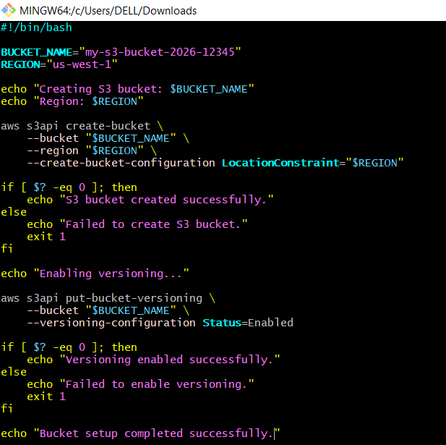
Screenshot 2: Script execution showing:
S3 bucket created successfully.
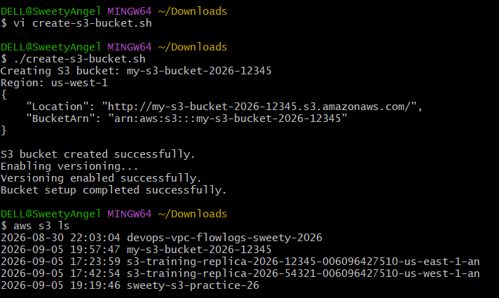

Screenshot 3: aws s3 ls showing the newly created bucket.
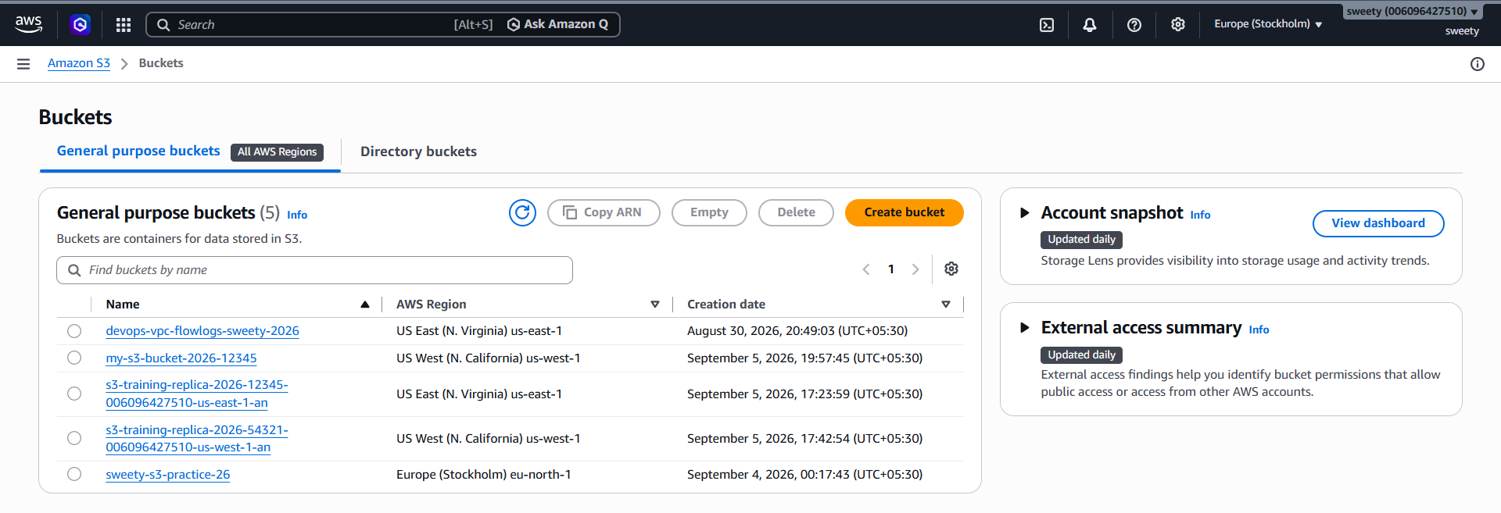
Conclusion
A Bash script was successfully created and executed to automate S3 bucket creation using AWS CLI.

8. Upload a 1 GB File to S3 Using CLI
Objective
To upload a large 1 GB file to an Amazon S3 bucket using the AWS CLI and verify the successful upload.
Steps Performed
Step 1 — Create a 1 GB test file
Since you're using Windows/Git Bash, you can create a test file with:
fsutil file createnew 1GB-test-file.bin 1073741824
Run this from Windows Command Prompt.
This creates a file of:
1 GB = 1,073,741,824 bytes
Then check the file size.
Step 2 — Upload using AWS CLI
Run:
aws s3 cp 1GB-test-file.bin s3://YOUR-BUCKET-NAME/
AWS CLI will display the upload progress.
Step 3 — Verify the upload
Run:
aws s3 ls s3://YOUR-BUCKET-NAME/
You should see something similar to:
1GB-test-file.bin 1073741824
You can also use:
aws s3api head-object \
--bucket YOUR-BUCKET-NAME \
--key 1GB-test-file.bin
This will show the object's metadata and size.
Evidence / Screenshots
Take screenshots of:
Screenshot 1: The local file showing approximately 1 GB.
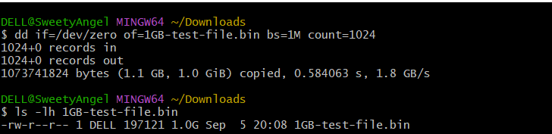
Screenshot 2: CLI upload command and upload progress.
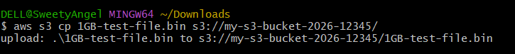
Screenshot 3: aws s3 ls showing the 1 GB object.
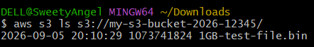
Screenshot 4: Optional head-object output showing:
ContentLength: 1073741824
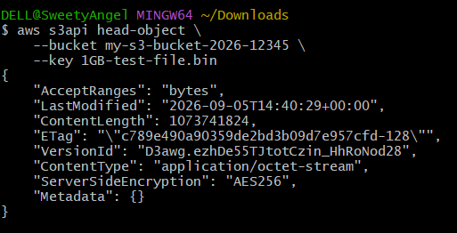
Shreenshot showing successful upload of 1GB file
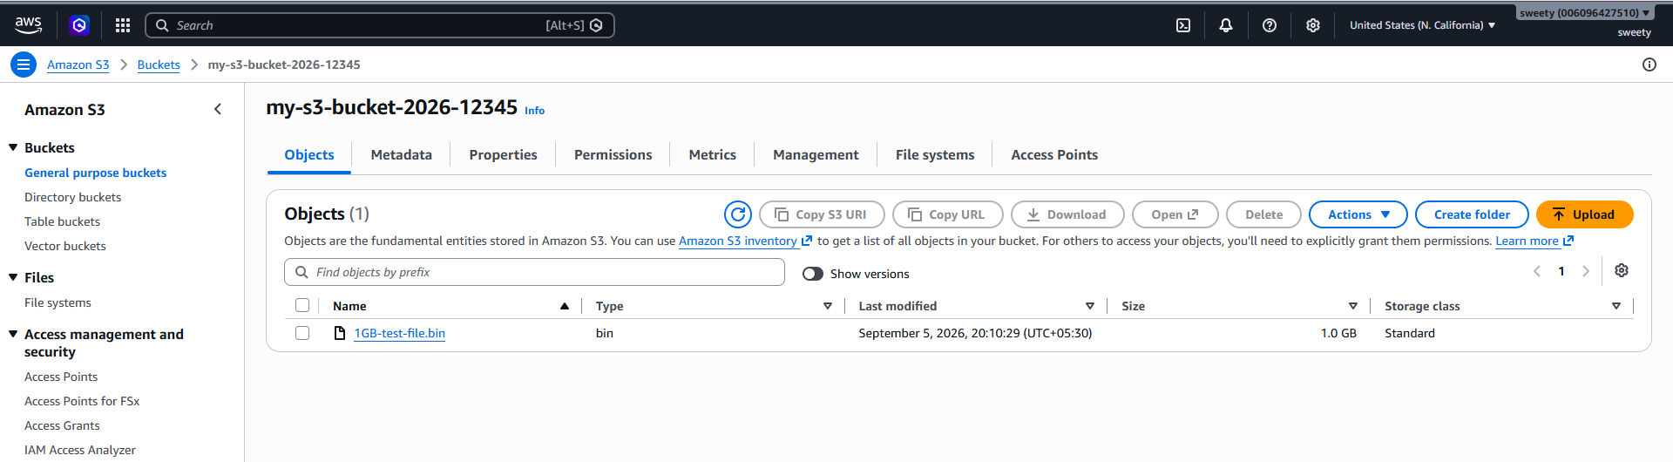
Conclusion
A 1 GB file was successfully created and uploaded to Amazon S3 using the AWS CLI. The uploaded object's size was verified using AWS CLI.

